The velocity profile of each line segment in M350 processing adopts an S-curve,
as shown in the diagram below:：

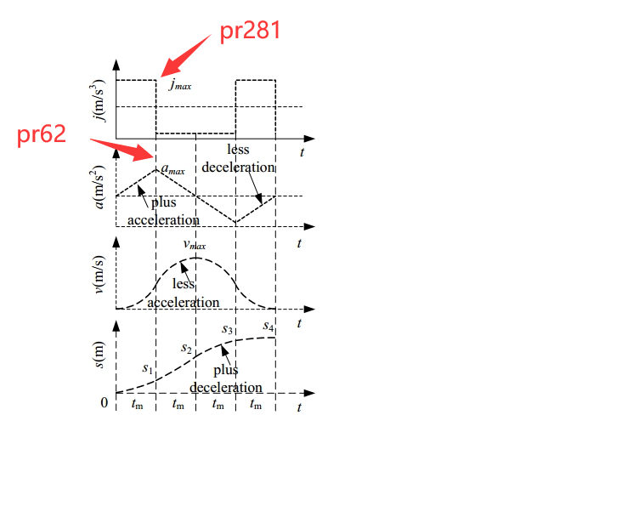

Pr62: Linear acceleration, unit: mm/s^2
Rate of change of velocity; maximum acceleration of the line segments of the S-curve, as shown in the diagram above;

Pr281: S-curve acceleration/deceleration parameter J, unit: mm/s^3
Rate of change of acceleration, i.e., the rate at which acceleration changes over time; as shown in the diagram above;
The larger the value, the faster the acceleration changes.

Pr280: Corner acceleration, unit: mm/s^2
The acceleration at the corner between two adjacent straight lines, which together with the angle of the corner, affects the speed of the corner;
The larger the value, the faster the corner speed for the same angle;

As shown in the diagram below:
Pr280 will affect the speeds V1 and V2;
V1 is the endpoint speed of line L1 and also the starting speed of line L2;
V2 is the endpoint speed of line L2 and also the starting speed of line L3.

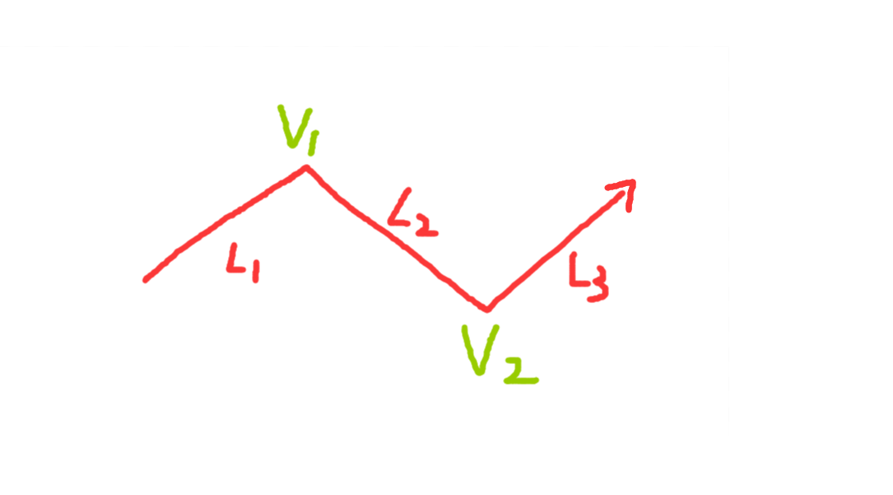

The velocity profile of each straight line (L1, L2, L3) follows an S-curve;
Taking line L2 as an example, its velocity profile is as follows:
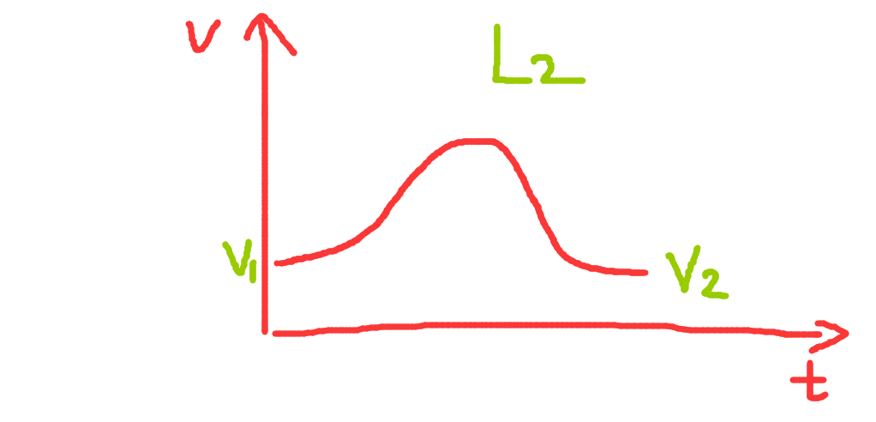

Parameter Setting Method:
If Pr281 == 0, then the actual S-curve acceleration/deceleration parameter J value will be automatically calculated based on the acceleration specified by Pr62;
For example:
When Pr62 == 300, the actual J parameter value is calculated as: 36000 mm/s^3;
If Pr281 is non-zero, then the actual J parameter value will be the value set by Pr281;

Similarly, if Pr280 == 0, then the corner acceleration value will be automatically calculated based on the acceleration specified by Pr62;
For example:
When Pr62 == 300, the actual corner acceleration value is calculated as: 720 mm/s^2;
If Pr280 is non-zero, then the actual corner acceleration value will be the value set by Pr280;

Example:
If you find that the velocity is slow, increasing Pr62 and Pr281 doesn't significantly improve the speed, and the machine tool vibrates too much, it may be because the corner speed between adjacent line segments is low, resulting in low starting speeds for each line segment; in this case, you can individually increase the value of Pr280;

The larger the values of Pr62 and Pr281, the faster the acceleration, but the machine tool impact may also increase;

Due to different machine tool characteristics, please set the values of Pr62, Pr281, and Pr280 reasonably and patiently according to the actual situation to achieve the best performance of the machine tool.

